COMBAT RULES

ATTRIBUTES

Before doing any calculation, adjust the following attributes if necessary:

* Every attribute has to be round to integer
* INS: min 1 - max 80
* ATT: Can be negative or positive
* Remaining attributes will have a minimum value of 1

ATTACK SUCCESS / FAIL

Attack roll

The chance to attack / quality of attack gets calculated with a D100 roll.

ATTACK% = 1D100

Success percentile

The maximum percentile in which an attack succeeds.

SUCCESS% = WEAPON% + DEX modif + INS mod

SUCCESS% will be limited to 75

where:

* WEAPON% = Weapon base percentage
* DEX mod = DEX/2 (rounded up)
* INS mod

| INS attribute | INS mod |
| --- | --- |
| 95-100 | 25 |
| 90-94 | 15 |
| 85-89 | 12 |
| 80-84 | 10 |
| 35-79 | 5 |
| 1-34 | 0 |

Attack Success / Fail

| ATTACK% | SUCCESS / FAIL |
| --- | --- |
| <= SUCCESS% | Attack succeeded |
| > SUCCESS% | Attack fails |

Critical percentile

The maximum percentile in which an attack is considered critical.

CRIT% = CFP * SUCCESS% / 100 (result rounded up)

Fumble percentile

The minimum percentile in which an attack is considered a fumble.

FUMBLE% = 1~~00 -~~ (100 - SUCCESS%) * CFP / 100 (result rounded down)

Percentiles showdown

IF attack SUCCEEDS:

| ATTACK% | TYPE OF ATTACK |
| --- | --- |
| <= CRIT% | Critical |
| > CRIT%  <= SUCCESS% | Normal |

IF attack FAILS:

| ATTACK% | TYPE OF ATTACK |
| --- | --- |
| > SUCCESS%  <= FUMBLE% | Failed |
| > FUMBLE% | Fumble |

Note: If FUMBLE% = 100, the player cannot make fumbles.

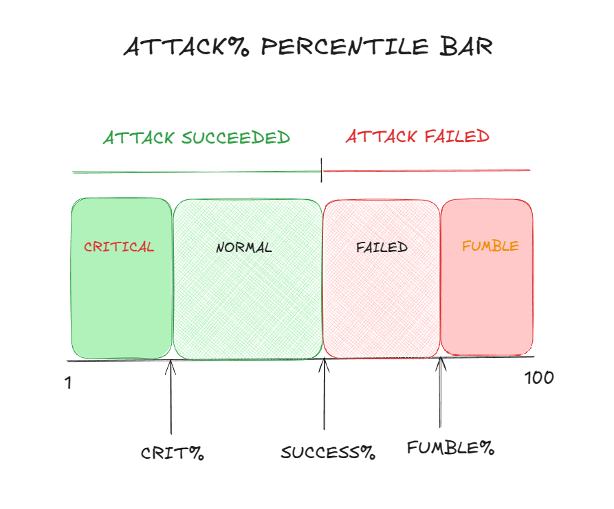

DAMAGE

**NORMAL ATTACK**

TOT. DAMAGE = (WEAPON ROLL x ATT mod 1 + ATT mod 2) / DEF mod (rounded up)

Min TOT. DAMAGE value = 1

ATT mod calculation

| ATTACK attribute | ATT mod 1 | ATT mod 2 |
| --- | --- | --- |
| 60+ | 1.25 | 15 |
| 45-60 | 1.2 | 15 |
| 20-44 | 1.15 | 10 |
| 1-19 | 1.1 | 6 |
| -10 to 0 | 1 | 4 |
| -20 to -11 | 0.9 | 2 |
| <-20 | 0.8 | 0 |

DEF mod calculation

TOTAL DEFENSE = TOTAL ARMOR defense + DEF attribute

| TOTAL DEFENSE | DEF mod |
| --- | --- |
| 400+ | 7 |
| 351-400 | 6 |
| 275-350 | 5 |
| 201-274 | 4 |
| 151-200 | 3 |
| 100-150 | 2 |
| <100 | 0 |

**CRITICAL ATTACK**

CRIT. DAMAGE = BCFA / 5 + WEAPON ROLL x CRIT mod 1 + CRIT mod 2

(rounded up)

The critical attack is not affected by any armor.

CRIT mod calculation

CRITICAL PERCENTILE = ( ATTACK% / CRIT% ) x 100

| Critical percentile | CRIT mod 1 | CRIT mod 2 |
| --- | --- | --- |
| 1-7 | 0.35 | 30 |
| 8-14 | 0.3 | 25 |
| 15-24 | 0.25 | 20 |
| 25-40 | 0.23 | 15 |
| 41-60 | 0.2 | 10 |
| 61-100 | 0.15 | 5 |

**FUMBLE**

FUMBLE DAMAGE = ( BCFA + WEAPON ROLL ) / 5 (rounded up)

Fumble Percentile = 100 x (ATTACK% - FUMBLE%) / (100 - FUMBLE%)

| Fumble Percentile | Fumble effect |
| --- | --- |
| 86-100 | Smash. The player is self-injured heavily.  Damage: FUMBLE DAMAGE (rounded up) |
| 61-85 | Hack. Self leg broken. The DEX attribute gets halved and from then onward it remains unaltered. |
| 31-60 | Fairytale. Player encounters the legendary glasses from X.G, El Erudito. Upon wearing them the sight gets blurred and annoyance takes over. Player pushes slightly a random fellow as he shouts “¡Tú eres tonto!”.  From then onward, he appears once in every turn. At the end of the round we will calculate the fellow to whom this effect shall apply in the following round.  Damage: 1D4 (insult).  Note: It will only be assigned one in a round. If a second player rolls the same interval, if will be substituted by the Slash fumble. |
| 1-30 | Slash. The player is self-injured slightly.  Damage: FUMBLE DAMAGE / 2 (rounded up) |

**LUCK**

Luck rolls will be thrown every turn when attacking and when defending.

NUM LUCK ROLLS = CHA / 20 (rounded down).

Roll 1D100 per LUCK ROLL

* If roll < 20 in one roll, the player has luck.
* If roll >= 20 Otherwise, the player has no luck.

Roll 1D100 afterwards:

| D100 roll | LUCK mod |
| --- | --- |
| 81-100 | Next round starts first. (It will only be assigned one in a round. If a second player rolls the same interval, we will ignore the result) |
| 60-80 | When a player attacks, a normal attack transforms into a critical damage. |
| 50-59 | Attacking:   * Normal attack: ATT mod 2 : + 80%   Defending: No magic received |
| 36-49 | Attacking:   * Normal attack: ATT mod 2 : + 40%   Defending: No magic received |
| 16-35 | Attacking:   * Normal attack: ATT mod 2 : + 20%   Defending: No magic received |
| 1-15 | When a player defends no damage received. |

MAGIC RESISTANCE

Throw 1D100

Illnesses

if D100 roll < MRES/4 illness not affected

Curses

if D100 roll < (MRES + CON x 2)/7 curse not affected

Stenches

if 1D100 roll < (MRES + affected attribute) / 5

TURN MANAGEMENT

Turn rolls will be thrown when starting a turn

Num. turn rolls in a turn = (CHA + DEX / 2 )/ 20 (rounded up).

Each player will roll a 1D2 for each num roll.

The turn order will be sorted in descending order by the number of successes. The first one will be the player with the biggest number of successes and the last one, the player with the lowest number.

If 2 or more players have the same number of successes, the player with the biggest CHA attribute will attack first. If characters have equal CHA attribute, the player with biggest DEX will attack.